Remotely Close Associations: Openness to Experience and Semantic Memory Structure
Supplementary Information
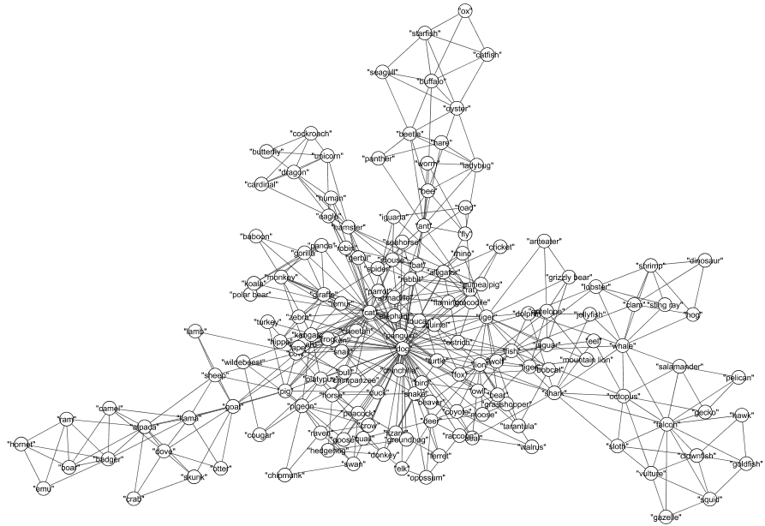
SI 1. Semantic network structure of the low Openness to Experience group

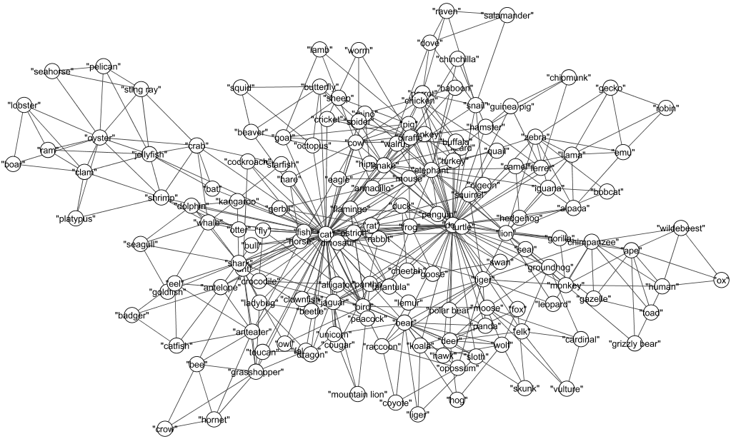
SI 2. Semantic network structure of the high Openness to Experience group

